The Hodgkin-Huxley Model for the propagating action potential.
$\frac{a}{2R_{2}θ^{2}}\frac{d^{2}V}{dt^{2}}=C_{M}\frac{dV}{dt}+{\overset{‾}{g}}_{K}n^{4}\left(V-E_{K}\right)+{\overset{‾}{g}}_{Na}m^{3}h\left(V-E_{Na}\right)+{\overset{‾}{g}}_{l}\left(V-V_{l}\right)$ (1)
$\begin{matrix}\frac{dn}{dt} & =α_{n}(1-n)-β_{n}n \\ \frac{dm}{dt} & =α_{m}(1-m)-β_{m}m \\ \frac{dh}{dt} & =α_{h}(1-h)-β_{h}h\end{matrix}$ (2)

Where
$a$ is the radius of the nerve
$R_{i}$ the specific resistance of the axonal intracellular space
$θ$ velocity at which the action potential travels
${\overset{‾}{g}}_{K}$ , ${\overset{‾}{g}}_{Na}$ potassium & sodium conductance

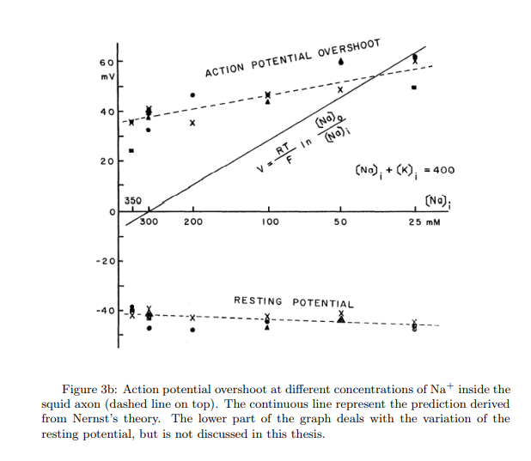
The Fitzhugh-Nagumo model
FitzHugh proposed a simplification of the original model consisting of a two-dimensional system, instead of four-dimensional system of the Hodgkin-Huxley.
$$\frac{dV}{dt}=-{\overline{g}}_{K}n^{4}\left(V-V_{K}\right)+{\overline{g}}_{Na}{m^{3}}_{∞}h\left(V-V_{Na}\right)+{\overline{g}}_{l}\left(V-V_{l}\right)+I_{appl}$$
The general form of the two-dimensional system FitzHugh and Nagumo:
$\frac{dv}{dt}=v\left(v-a\right)\left(1-v\right)-ω+l$
$\frac{dw}{dt}=βv-γω$
The Heimburg-Jackson model:
Heimburg and Jackson tried to address the electrical aspects of action potentials by adopting a thermodynamic framework, Where the action potentials could be considered as sound waves. Restricting the problem to one dimension, using the equation for the propagation of sound-waves in compressible media & adding an arbitrarily dispersive term.

